Digital Technologies Glossary
A
abstraction
The process of reducing complexity to define the main idea, problem or solution. This is achieved by hiding details to focus on a manageable number of aspects.
acquire (data)
Ways of collecting and accessing data from a range of sources, e.g. data could be collected by counting objects and accessed from a file provided by the teacher.
advanced features
Functions and peripherals that exploit the capabilities of digital tools (hardware and software), e.g. using a style sheet to automate formatting and a drone to capture field data.
agile projects
An approach to completing projects that takes an iterative path rather than a linear one. It involves incremental improvement and continual evaluation and feedback from the users.
agreed conventions
Rules or preferred standards about how content is to be created, located and communicated, e.g. using agreed formatting styles for headings and charts, and a common file-naming system.
algorithms
Precise description of the steps and decisions needed to solve a problem. Algorithms often involve iterative (repetitive) processes and can be represented, e.g. as flowcharts and pseudocode.
apps
Software originally designed to run on mobile devices and to be quite targeted in its purpose; an app (abbreviation of application) can now be considerably broader in its purpose.
ASCII (American Standard Code for Information Interchange)
An early encoding system, later extended, used to represent characters, including 0–9 and a–z, in computer systems. For example, capital P is represented by the number 80 in ASCII, which in turn is represented as 0101000 in binary. See also data representation.
Asia/Asian
Geographically, the largest continent, bounded by Europe and the Pacific, Arctic and Indian oceans. It can be described in cultural, religious, historical and language boundaries or commonalities.
attributes
Characteristics or properties that identify and describe entities within a database, e.g. an attribute of an entity 'person' could be name or date of birth.
B
binary
A base 2 number system that uses 2 states or allowable values to represent data, such as the off and on state of a light switch and the 0 and 1 values in the binary number system.
bitmap
A representation in which each item corresponds to one or more bits of information, especially the information used to control the display of a computer screen.
branching (decision)
A control structure that involves making a decision based on defined conditions and the data provided, and determining the next step, e.g. if it is raining take a raincoat, else take a hat.
C
comparison operators (branching)
Algorithmic expressions that compare values, returning true or false to make decisions, e.g. the operator '<' determines if one value is less than another.
components  The hardware and software parts of a digital system that perform specific functions and are needed for the system to operate, e.g. input, processing, storage and output components. | 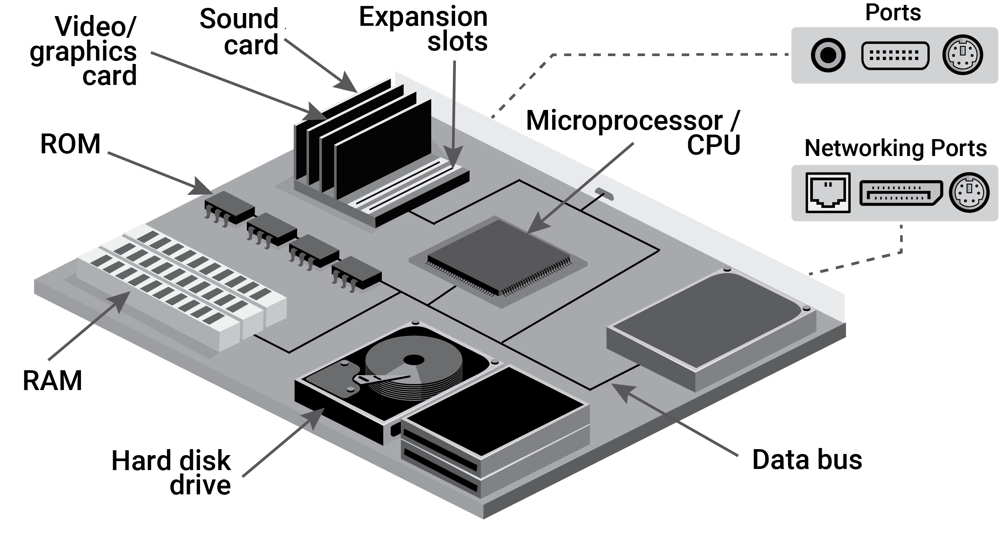
computational thinking
A way of thinking which helps to organise data logically by breaking down problems into parts; defining abstract concepts; and designing and using algorithms, patterns and models.
control structures
The decision-making building blocks of an algorithm that determine or control the flow of which statements are executed. The 3 control structures are sequence, branching and iteration.
Country/Place
Spaces mapped out that individuals or groups of First Nations Peoples of Australia occupy and regard as their own and having varying degrees of spirituality. They include lands, waters and sky.
cyber security
Technologies, processes and practices taken to protect digital systems and networks from theft or damage to their hardware, software, data or to the disruption of services.
cyber security threats
Malicious acts designed to damage or steal stored and transmitted data, or to disrupt networked digital systems, e.g. distributed denial of services attacks, phishing and ransomware.
D
data
A general term for a set of observations or measurements collected during an investigation. Primary data is collected by the user; secondary data is collected by others.

data compression
The process of encoding data; using less data than the original representation to reduce size. Compression can maintain (lossless) or reduce (lossy) data.
data representation
How data is represented and structured symbolically for storage and communication, by people and digital systems, e.g. symbols can communicate ideas and whole numbers can represent letters.
debug
A systematic process that involves finding existing errors in a program such as identifying error messages in lines of code, fixing them and validating if the changes made are correct.
decompose
A process to separate complex problems into manageable parts to allow problems to be more easily understood and solved. Iterative questioning helps to understand a problem and reveal possible solutions.
design criteria
Criteria used to determine if the proposed solution meets the requirements. They are drawn from the solutions requirements, user stories, if appropriate, and constraints.
design process
A process that involves investigating and defining; generating and designing; producing and implementing; evaluating; and collaborating and managing to create designed solutions that meet needs.
design thinking
An approach which helps people to empathise and understand needs, opportunities and problems; generate, iterate and represent innovative, user-centred ideas; and analyse and evaluate those ideas.
digital footprint
The total set of traceable data left behind by a person using digital tools. A person’s digital footprint includes active data (e.g. emails) and passive data (e.g. browser history).
digital system
A system that processes data in binary, made up of hardware, controlled by software, and connected to form networks, e.g. a laptop and a networked banking system.
digital tools
Digital hardware, software, platforms and resources used to develop and communicate learning, ideas and information.
divide and conquer
A technique for breaking down a problem. It involves dividing a problem into smaller sub-problems, solving the sub-problems (conquer) and combining the results to get a final solution.

E
encryption
A cryptographic process that protects data stored and transmitted by digital systems. It involves encoding data so that it can only be decoded by the intended recipient using a secret key.
entities and their relationships
Key elements of a data-modelling technique that represents the entities (e.g. employees and their department) and their relationships (e.g. one department has many employees).
F
features
Distinctive properties, characteristics, functions and qualities of an object, material, living thing, system or event that affect how it performs or operates.
flowcharts
A diagrammatic representation of an algorithm. Steps and decisions are represented by specific-shaped symbols and arrows indicate sequence.
G
general-purpose programming language
A text (rather than visual) programming language that is designed to solve a wide range of problems. It can often also support multiple programming styles.
H
hardware
Physical components of a digital system. Hardware comprises internal components (e.g. motherboard and central processing unit) and external peripherals (e.g. microphone and keyboard).
hardware specifications
Technical descriptions of the capabilities of hardware components, e.g. descriptions of storage memory size in gigabytes and speed of the central processing unit in gigahertz.
heading hierarchies
Ordering or ranking systems that group content into main headings and subheadings and help with locating information, e.g. a range of font sizes from large to small shows their relative importance.
I
input
Data acquired from a user or digital system or sensed from the environment that an algorithm or program can respond to.
integers
Whole numbers including those with negative signs, e.g. -4, -2. Sometimes defined as numbers that can be written without fractional components.
interactive content
Output that involves the user being able to change the behaviour, view or result by providing some input, e.g. interactive quizzes, training manuals, visualisations with sliders and games.
interactive tools
Software that supports users being able to change the behaviour, view or results by providing some input. Interactive tools (e.g. spreadsheets) help users draw conclusions and make predictions.
internal components  Hardware components inside a digital system for storing data (e.g. random access memory), for processing data (e.g. central processing unit) and for connectivity purposes (e.g. motherboard). | 
internet
Globally interconnected network of digital systems communicating using standardised internet protocols such as TCP/IP.
iteration
Repetition of a set of steps or instructions in an algorithm or program, e.g. a loop in a flowchart, a repeat block of FOR, WHILE statements.
J
K
L
logical operators
An operator or function to combine Boolean (true or false) values, including AND, OR and NOT, e.g. the 'x AND y' operation is only true if both 'x' and 'y' are true.
M
markup
Tags (or annotations) created by a markup language such as HTML, XML or SVG that define the separate elements within a document. Markups tell a browser how a file should be arranged and displayed.
model
A visual or physical representation that describes, simplifies, clarifies or gives an explanation of the workings, structure or relationships within an object, system or idea.
modular programs
Programs separated into individual well-defined modules of code that perform related tasks. Each sub-divided program or module performs one aspect of the required functionality of the solution.
multidimensional data
Data that has many dimensions and values. The data is structured in many rows and columns and can be modelled and viewed in multiple dimensions, facilitating interpretation.
multi-factor authentication
A security system that typically requires 2 or more authentication factors to identify a person for access purposes, e.g. a personal identification number, a swipe card and a biometric.
multiple alternatives (branching)
Algorithmic expressions that involve making multiple yes or no decisions based on defined conditions and the data provided.
N
nested control structures
Control structures that are placed within other control structures, e.g. IF, THEN, ELSE block placed within a FOR, NEXT loop.
networked digital systems
Digital systems connected via the internet or bluetooth devices that allow data to be transmitted. The connection can be established via cables (wired) or without the use of cables (wireless).
O
object-oriented programming language
A programming language which supports declaring classes to define objects and their behaviour. Objects combine data (attributes) and actions that can be performed on that data (methods).
online safety
The practice of individuals protecting themselves and others from online harm and risks, which might jeopardise their personal information, lead to unsafe communications or affect their mental health and wellbeing.
outliers
A data point that appears to differ significantly from other data points in a set of data or a trend. Due to variability or an error an outlier may be excluded from analysis.
P
passphrases
A string of words that is used for authentication purposes to gain access to a digital system. They need to be memorable to the user but difficult to guess or determine.
performance
Measurements of the accuracy, speed and efficiency with which digital systems can carry out tasks, e.g. a hard disk's performance can be measured by how fast it transfers data.
peripherals
Digital components that can be externally connected to a digital system to extend its functionality but are not essential to the operation of the system, e.g. a speaker and a printer.
personal accounts
Accounts used on different platforms (websites and apps) for school and home use, e.g. students can have personal accounts to gain access to music, gaming, sport and school resources.
phishing
Fraudulent practice of sending untargeted emails asking people to reveal sensitive data such as bank details or encouraging people to open a malicious attachment or download malicious content.
privacy
The ability of an individual or group to control who can use or see information about themselves. Information privacy is related to how personal data and information is handled.
project management
Detailed proposals for managing projects so they can meet the design criteria, e.g. plans usually list and sequence tasks, and indicate the required resources, costs and timelines.
project management tools
Software that supports the planning and tracking of projects. Project management tools provide visualisations of the workflow, timeframe and resources involved in completing a project.
prototype
A trial model used to test an idea or process and to inform further design development. Its purpose is to see if and how well the design works. It is tested by users, programmers and analysts.
pseudocode  English language statements that describe the steps in an algorithm in a clear, unambiguous way. It can be easily translated into code using a programming language. | 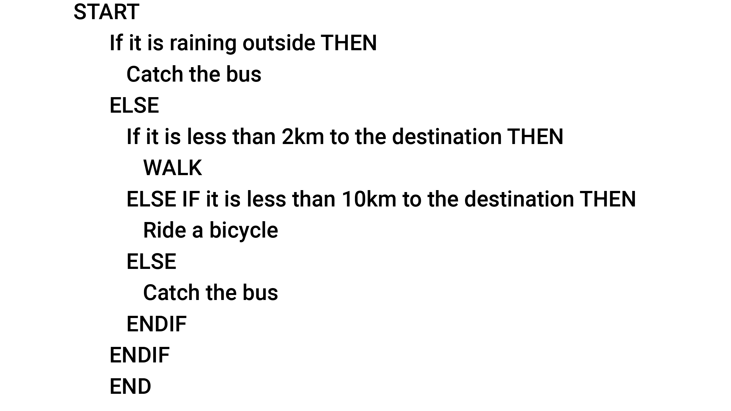
Q
query
A question or request for data results from a database, e.g. queries can be actions, such as combining data to produce more in-depth responses or they can be simply answers to questions.
R
real-world problems
Problems that exist; they are authentic and not hypothetical or do not happen in fiction. They draw on actual events or situations and can possibly be solved through computation.
relational database
A type of database that is structured to recognise relationships between stored data and information, e.g. data organised in tables can be linked based on data that is common to each.
represent data
How data is expressed and structured symbolically for storage and communication by people and in digital systems, e.g. people read symbols, and digital systems use binary to represent letters.
represent documents
Webpages represented as models showing their separate elements: content (text), structure (e.g. headings and paragraphs) and presentation (e.g. style) See also documents (represent).
S
security
Assurances that resources such as data are protected, free from risk and reliable, e.g. data is encrypted when being transmitted.
sequencing
A control structure that determines that each line of code (or statement) is followed in order to the end of the program no matter what conditions are met.
single-table database
Databases structured as single tables with fields, records and files. Also known as flat-file databases or simply a flat file. Single-table databases cannot represent relationships between entities.
software
A set of programs, procedures and routines associated with the operation of a digital system.
structured data
Data that is organised on a basis of a predefined model or schema and formatted in a way that shows relationships such as fields, rows, columns. This structuring makes the data more easily searchable.
styling
Representation of how a webpage is laid out, such as heading styles and placement of images.
supply chain vulnerability
Possible risks to a system involved in supplying a product or service (supply chain) to a consumer, e.g. a cyber attack resulting in malicious code stopping a system from functioning correctly.
systems thinking
A way of thinking holistically about the interactions and interconnections that shape the behaviour of systems. Systems thinkers consider the purpose, parts, order of events and feedback in a system.
T
tablets
Flat, thin, mobile computers fitted with a touchscreen display and a rechargeable battery. Finger or stylus gestures replace the conventional computer mouse.
test cases
Sets of specifications or conditions and expected results used to systematically test if software solutions satisfy design criteria.
trace
The process of following an algorithm precisely to confirm it produces the expected output for a given input, e.g. a trace table allows for the manual checking of any logical errors.
traditional owners
The original owners of a particular region based on their traditional and cultural associations with the land and who have ongoing traditional and cultural connections to that Country/Place.
trusted adults
Reliable people who children feel comfortable talking to if they are upset or need help when engaged in online activities. They might include family members, carers, teachers.
types of data
General categories of data that can be transmitted between digital systems, e.g. text (e.g. text message), numeric (e.g. sporting results), sound (e.g. streamed music) and images (e.g. photo).
U
user experience
The process used to create products that meet the design criteria and provide meaningful and relevant experiences to users. It encompasses all the end users' interactions with a product.
user interface
The characteristics of the boundary between users and a digital system or the way in which users interact with hardware or software.
user stories
Short, simple descriptions of key software features that end users want from a digital solution. They often describe why the user wants particular features, and are part of the iterative design process.
V
variables
Data values that can change depending on the conditions during the running of a program. Variables are the named stored locations where the data values are held.
visual programs
Programming language where the program is mainly represented and manipulated graphically rather than as text. Statements and control structures within graphic blocks can be composed to form programs.
visualise data
Process of presenting data in a summarised form to help with communication and analysis, e.g. sorting and presenting data as a chart showing spending trends to help make financial decisions.
W
whole numbers
Values represented as integers in digital systems that in turn are represented as binary numbers, e.g. capital A is represented by the whole number 65, or 01000001 in binary.
wired
Digital systems that use cables (or wires) to establish connections to the internet and allow the transmission of data to other digital systems.
wireless
Digital systems that can transmit data to other systems without using cables,e.g. data can be transmitted via microwave signals, radio frequencies and bluetooth and infrared devices.
workloads
The ability of digital systems to handle and process computational requirements, e.g. the effort required by a gaming server to meet storage, communication and processing demands.
X
Y
Z

